Title
Article title (maximum 15 words).

Abstract:
Structured abstract (200–250 words).

Keywords:
Provide five keywords; each keyword should contain a maximum of two words.

1 Introduction (Heading 1)

2 Literature review (Heading 1)

2.1 Heading 2

2.1.1 Heading 3

3 Method

3.1 Study Design

3.2 Participants

3.3 etc

4 Findings
Table 1. Tables should only contain horizontal lines at the top, below the header, and at the bottom
Variable | Frequency | Percentage
Variable 1 | 20 | 20
Variable 2 | 20 | 20
Variable 3 | 60 | 60
Table numbers must be referred to in the narrative text, for example "As shown in Table 1…"
The Figure numbers must also be referred to in the narrative text, for example "Figure 1 shows..."
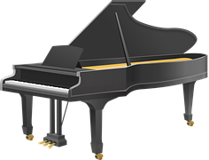
Figure 1. Minimum image resolution of 100 DPI with no borders
The source of all figures must be explicitly cited (e.g., "Source: ..." or cited according to APA 7th edition guidelines if adapted/reprinted).

5 Discussion

6 Conclusions

7 Limitations and future research

References
References must follow the APA 7th edition style.

